**Microcontroller-Implemented LED Chaser**

STUDENT NAME: G.P.D. THAMARA

STUDENT NUMBER: EC/2021/005

**Source Code**

void knightrider(void){

int i;

TRISB = 0x00;

PORTB=0x01;

for( i =1 ; i<=7 ;i++){

PORTB = (PORTB <<1);

Delay_ms(100);

}

for( i =7 ; 7>=i ;i--){

PORTB = (PORTB >>1);

Delay_ms(100);

}

}

void main(){

CMCON = 0x07;

TRISA = 0xff;

while(1)

knightrider();

}

**Circuit**

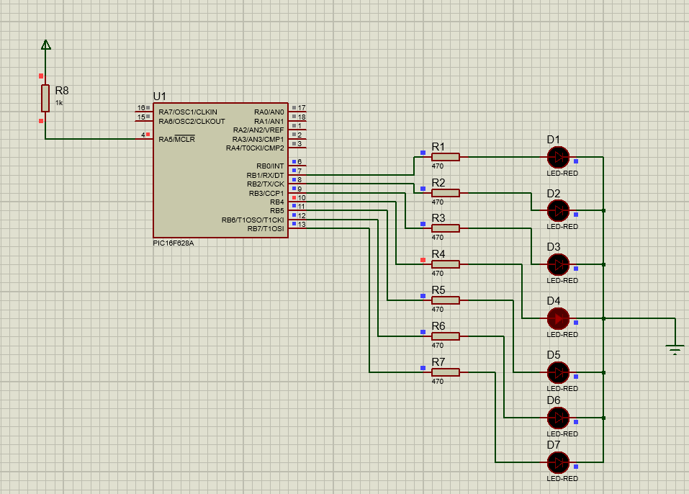

**Discussion**

The LED chaser circuit implemented using a microcontroller demonstrates fundamental embedded system concepts such as timing control, digital output, and loop iteration. The code utilizes a for loop with an integer variable i to shift a single high bit across PORTB, creating a visual scanning effect across eight LEDs. The Delay_ms(100) function introduces a 100 ms delay between each LED transition, making the motion visually perceivable and aesthetically pleasing. The use of bitwise shifting operations (<< and >>) efficiently manipulates LED positions without complex logic. However, a logical flaw exists in the reverse loop condition for(i = 7; 7 >= i; i--), which does not execute due to the condition being false at the start. Correcting this to i >= 1 ensures complete back-and-forth motion. The initialization steps, such as setting TRISB = 0x00 and disabling the comparator module with CMCON = 0x07, are crucial for proper pin configuration and to prevent unexpected behavior.